Docker从1.13.x版本开始，版本分为企业版EE和社区版CE，版本号也改为按照时间线来发布，比如17.03就是2017年3月，有点类似于ubuntu的版本发布方式。

企业版自然会提供一些额外的服务，当然肯定也是收费的。企业版说明https://blog.docker.com/2017/03/docker-enterprise-edition/

社区版分为stable和edge两种发布方式。

stable版本是季度发布方式，比如17.03, 17.06, 17.09

edge版本是月份发布方式， 比如17.03, 17.04......

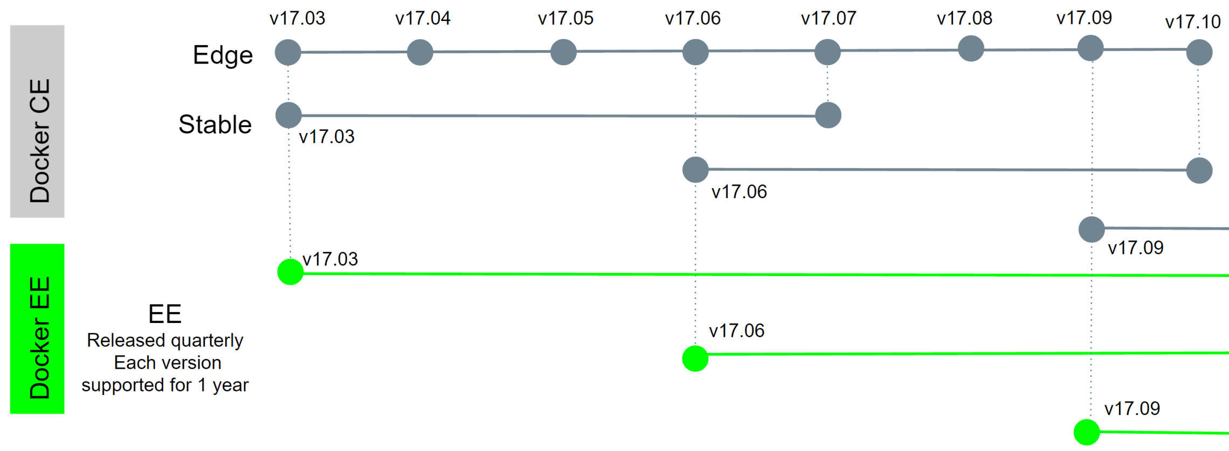

Docker的linux发行版的软件仓库从以前的https://apt.dockerproject.org和https://yum.dockerproject.org变更为目前的https://download.docker.com, 软件包名字改为docker-ce和docker-ee。

https://download.docker.com/linux/static/stable/x86_64/

docker registry v2版本的http api 一直没有找到合适的，自己通过阅读官方文档整理了一下。

## 概要

|  |  |  |  |
| --- | --- | --- | --- |
| method | path | Entity | Description |
| GET | /v2/ | Base | Check that the endpoint implements Docker Registry API V2. |
| GET | /v2/<name>/tags/list | Tags | Fetch the tags under the repository identified by name. |
| GET | /v2/<name>/manifests/<reference> | Manifest | Fetch the manifest identified by nameand referencewhere referencecan be a tag or digest. A HEADrequest can also be issued to this endpoint to obtain resource information without receiving all data. |
| PUT | /v2/<name>/manifests/<reference> | Manifest | Put the manifest identified by nameand referencewhere referencecan be a tag or digest. |
| DELETE | /v2/<name>/manifests/<reference> | Manifest | Delete the manifest identified by nameand reference. Note that a manifest can only be deleted by digest. |
| GET | /v2/<name>/blobs/<digest> | Blob | Retrieve the blob from the registry identified bydigest. A HEADrequest can also be issued to this endpoint to obtain resource information without receiving all data. |
| DELETE | /v2/<name>/blobs/<digest> | Blob | Delete the blob identified by nameand digest |
| POST | /v2/<name>/blobs/uploads/ | Initiate Blob Upload | Initiate a resumable blob upload. If successful, an upload location will be provided to complete the upload. Optionally, if thedigest parameter is present, the request body will be used to complete the upload in a single request. |
| GET | /v2/<name>/blobs/uploads/<uuid> | Blob Upload | Retrieve status of upload identified byuuid. The primary purpose of this endpoint is to resolve the current status of a resumable upload. |
| PATCH | /v2/<name>/blobs/uploads/<uuid> | Blob Upload | Upload a chunk of data for the specified upload. |
| PUT | /v2/<name>/blobs/uploads/<uuid> | Blob Upload | Complete the upload specified by uuid, optionally appending the body as the final chunk. |
| DELETE | /v2/<name>/blobs/uploads/<uuid> | Blob Upload | Cancel outstanding upload processes, releasing associated resources. If this is not called, the unfinished uploads will eventually timeout. |
| GET | /v2/_catalog | Catalog | Retrieve a sorted, json list of repositories available in the registry. |